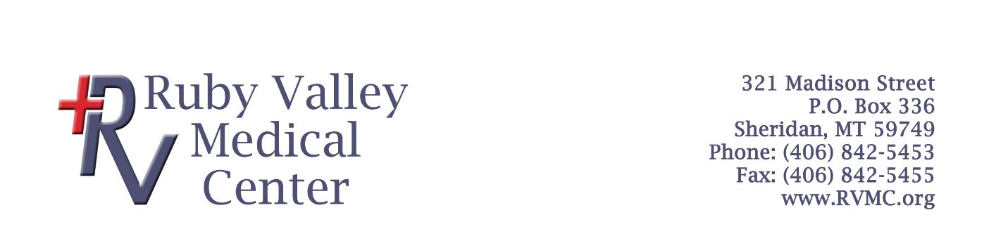
Clinical/Medical Laboratory Scientist Job Description

Summary
Performs medical laboratory tests and procedures to provide data for diagnosis, treatment, and prevention of disease by performing the following:
Essential Duties and Responsibilities (and others, to be assigned)
- Conducts chemical analyses of body fluids, such as blood and urine, to determine the presence of normal or abnormal components.
- Studies blood cells, their numbers, and morphology.
- Performs blood group typing and compatibility for transfusion purposes.
- Analyzes test results.
- Performs quality control studies to ensure accuracy of clinical data.
- Performs routine preventative maintenance on assigned instruments and equipment according to established schedules and procedures, including basic troubleshooting as needed.
- Records any repairs, replacements, and maintenance needed of equipment on electronic/paper logs.
- Must be proficient in analyzer and instrument operation, quality control, calibration, and maintenance.
- Proficient in blood draws, therapeutic phlebotomy.
- Work on call for ER coverage at night.

Supervisor Responsibilities
None. The CLS/MLS will report directly to the Laboratory Manager.

Qualifications
To perform the job successfully, an individual must be able to perform each essential duty satisfactorily. The requirements listed below are representative of the knowledge, skill, and/or ability required. Reasonable accommodations may be made to enable individuals with disabilities to perform the essential functions.

- Education and experience:
Bachelor’s Degree from a four-year college or university with successful completion of internship. Must have passed a technician’s examination offered by a national certifying body (ASCP, AAB, etc.) for Medical/Clinical Laboratory Scientists. 1-2 years of experience preferred.

- Language Skills:
Ability to read, analyze, and interpret common scientific and technical journals, financial reports, and legal documents. Ability to respond to common inquiries or complaints from customers, regulatory agencies, or members of the business community. Ability to write speeches and articles for publication that conform to prescribed style and format. Ability to effectively present information to top management, public groups, and/or boards of directors.

- Reasoning Ability: Ability to define problems, collect data, establish facts, and draw valid conclusions. Ability to interpret an extensive variety of technical instructions in mathematical or diagram form and deal with several abstract and concrete variables.

Certificates, Licenses, and Registrations
Must be licensed in the State of Montana as a Clinical Laboratory Scientist and must have certification from national certifying body (ASCP, AAB). Must maintain competency and complete required continuing education.

Physical Demands
The physical demands described here are representative of those that must be met by an employee to successfully perform the essential functions of this job. Reasonable accommodations may be made to enable individuals with disabilities to perform the essential functions.
- Employee must be able to effectively communicate with other hospital staff, patients, and the public. This includes hearing, speech, and sight. Corrective devices are allowed, but laboratory staff must be able to pass a color blind test upon hire.
- Ability to safely lift and carry up to 50 pounds, manipulate joints, kneel/sit/stand for extended periods, and maintain adequate physical condition to perform the functions of the job, as required. This list is not all-inclusive and may change or evolve as needs of the laboratory dictate.

Work Environment
While performing the normal and regular functions of this job, the employee is occasionally exposed to moving or mechanical parts, toxic or caustic chemicals, infectious tissues or samples, and risks electrical shock. Additionally, equipment necessary for the storage of chemical reagents or biological specimens and the clinical testing of these same items permit exposure to noise that is unavoidable. All attempts will be made to limit the amount of noise to avoid permanent damage or hearing loss. As such, the noise level in the lab is low to moderate.

Signature:_______________________________________ Date:__________________________

Print Name:_____________________________________

